Howard Junior Forest School Handbook

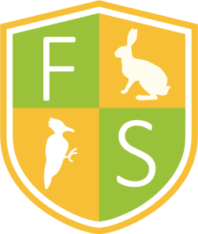

Written by Miss E Newell
Signed: Miss E Newell

Reviewed and updated on 01.09.25
Contents
Introduction to Forest School  What does Forest School look like at Howard Junior School?  Howard Junior Forest School rules  Staffing and responsibilities | Pages  3  5  5
Health and Safety at Howard Junior Forest School  Risk Management  First aid, accident and emergency procedure  Toileting, clothing, and drinking water procedures  Lost child, uninvited stranger  Cancellation procedure  Responsibilities  Tool policy and Safety  Fire policy and Safety  Food Hygiene | Pages  6  8  9  10  11  11  12  15  19
Child protection and Equality  Safeguarding procedure  Equal opportunities and inclusion in Forest School  Behaviour and anti-bullying  Use of photographs  Parental consent and agreement  Daily operating procedure  Environmental/Sustainability  Appendices | Pages  19  20  20  20  22  23

What does Forest School look like at Howard Junior School?
Forest School comes from Scandinavian culture and involves being in nature and being outside. The ethos of Forest School is that it aims to improve the children's well-being, giving children confidence, self-esteem and resilience through being outside mainly in woodland areas and gives them time and space to develop skills and interests through practical hands-on experiences. Forest School promotes the environment and its future sustainability. Our Forest Sessions will be influenced by the children's interests, abilities and experience. During Forest School children will be able to explore and connect with the natural world, work with tools, play and learn the boundaries of behaviour by managing risks.
Forest School has certain principles:
- It is a long-term process and sessions are regular
- Forest School takes places in a woodland or natural environment and develops a relationship between the participant and the natural world
- It is learner-centred
- Promotes the holistic development
- Forest School supports participants taking supported risks
- Forest School must be run by qualified members of staff
We will visit the Howard Junior Forest School site on a regular basis.
Forest School is fun!
During the first Forest School session the Forest School leader will observe children and fill in a pre-Forest School questionnaire (see appendix 1) to find out about children’s levels of self-esteem, resilience and confidence amongst other factors. When the children leave Forest School the Forest School Leader will fill in this same questionnaire to show the impact Forest School has had on the children. Children will be assessed throughout and the programme will follow the needs and interests of the children.
Forest School has a blog section on the school website to show what the children have been doing at Forest School.

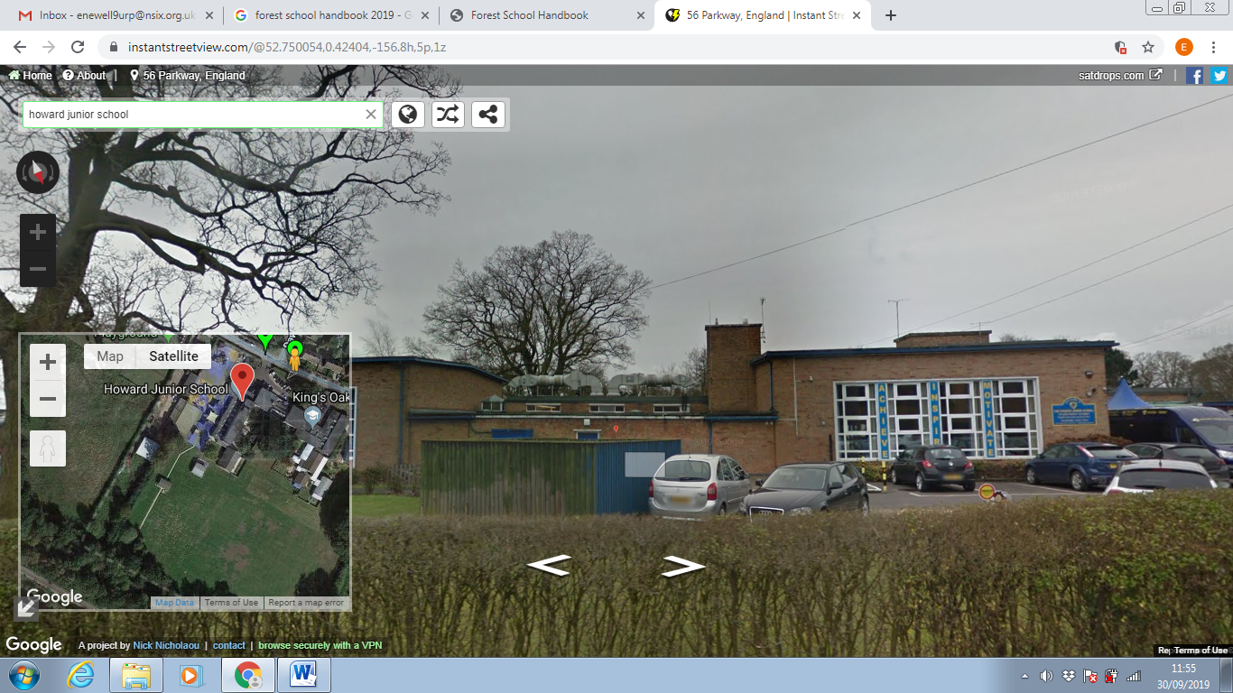
This is a map showing Howard Junior School and to the bottom left is where the Forest School site is and where Forest School sessions will take place, children will walk down to the Forest School site along the path on the school field, this is within school grounds as is the Forest School site.

The Forest School Site currently looks like this:
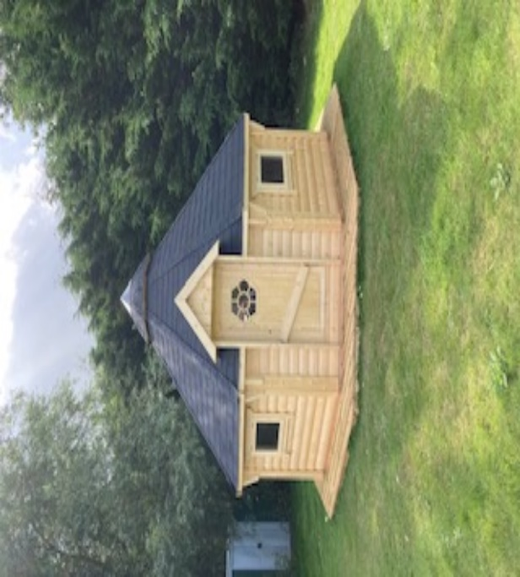
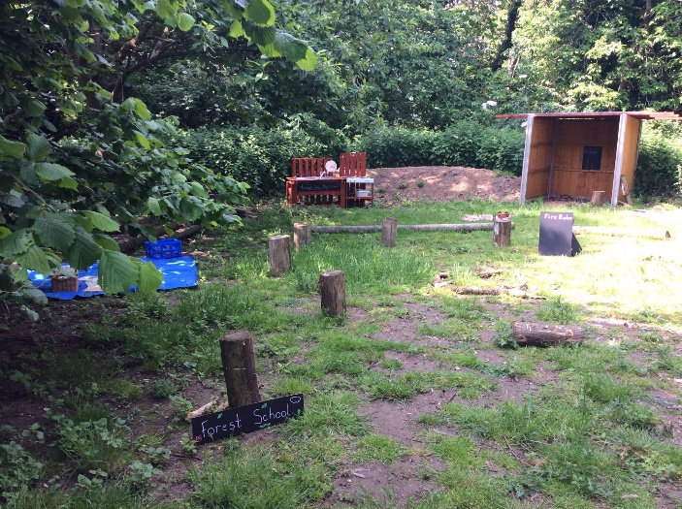

Howard Junior Forest School Rules

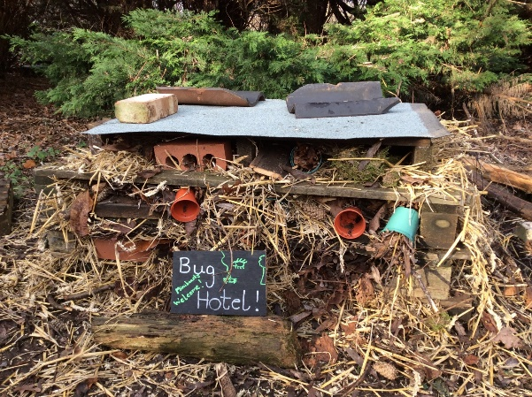
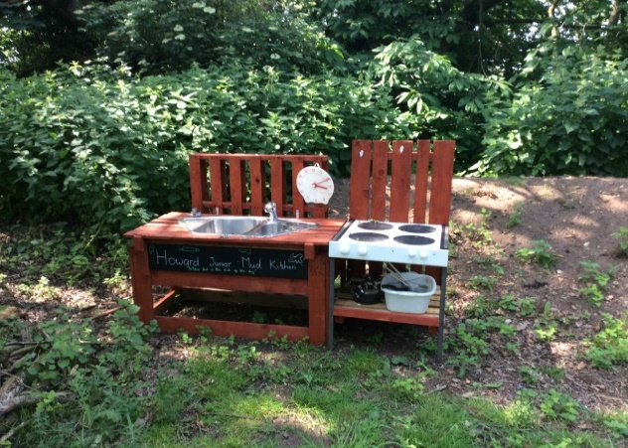

Howard Junior Forest School Rules
When beginning the Forest School each Forest School group will come up with their own rules. This will give them control over their Forest School journey. The rules will be guided by myself and reflect the Forest School ethos. We will also have specific rules for certain activities.
This is a picture of an example of current rules:
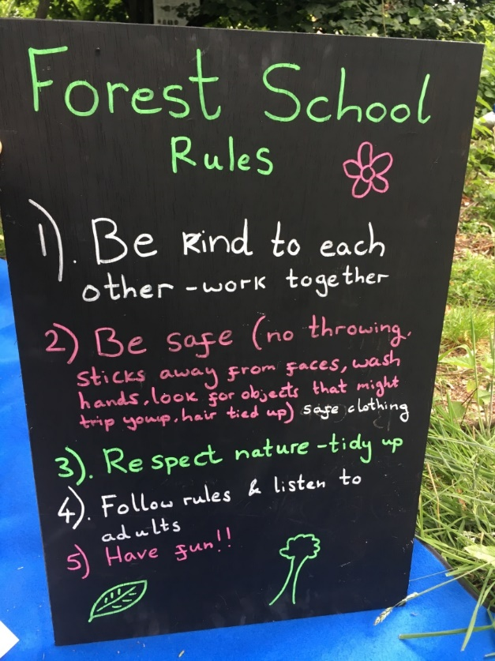

Staffing and Responsibilities
Name | Job role
Mr Paull | Principal
Miss E Newell | Qualified Forest school leader (Level 3)  Qualified teacher
Mrs Hopkins | Deputy Principal  SENDCO  Designated Safeguarding Lead

It is the responsibility of the Principal to ensure that the school has the correct insurance to cover the activities carried out in Forest School sessions.
A level 3 forest school leader must always be present for a Forest School session. If no Forest School leader is present, outdoor learning sessions can still happen in the woodland area, but Forest School related activities must not take place.
All staff and volunteers have a responsibility to ensure that they follow the school policies.
First aid can be carried out by any of the staff members present at forest school (with First Aid training), however, it is advised that a 'Forest School first aid' trained staff member (Miss Newell) oversees and is aware of any first aid carried out whilst at Forest School. Their outdoor first aid qualification must be renewed every three years (expiring June 2028). Staff are to follow the usual procedures to log any first aid in the main school office book.

The Forest School Leader must:
- Look after first aid kit and fill in school first aid log book if needed
- Advise children of how to stay safe at Forest School.
- Undergo risk assessments before every session and before any specific activity that requires a separate risk assessment e.g. tool use and fire risk assessments.
- Ensure tools and materials are in good working order
- Keep parents and staff informed about Forest School by having a Forest School blog section on the school website, having a Forest School display in school, making information booklets for parents... etc).
Health and Safety at Forest School
Risk Management Policy
Forest School includes some elements of managed risk for the children overseen by the Forest School leader. The Forest School approach places importance on managing risks and giving children the chance to take risks also. Risk is important for Forest School as it teaches children to take responsibility for their own safety and gives them a sense of being trusted and being in charge of this for themselves. This means children will learn about how to take safe risks and how to be responsible for their own safety. The Forest School leader will evaluate risks of Forest School activities and consider if the benefits outweigh the risks and control measures will be put in place to reduce the likelihood of a risk happening, this is a risk-benefit analysis. Daily risk assessments, risk assessments before each session, seasonal, weather risk assessments and specific assessments will be carried out.
Forest School believes that managed risk is important and there are many benefits to taking managed risks. Our Forest School provides a safe and supportive learning environment for children to learn and develop about risks, challenges and learning to keep themselves safe. Risk assessments are always carried out and children are involved in this process also for example we will come up with rules together guided by the Forest School Leader. The Forest School site, daily weather and the species present will also be taken into account and be risk assessed prior to all Forest School sessions.
The ratio for Forest School will be 1:6 including the Forest School Leader, however this can change in some circumstances e.g. Forest School Leader assesses the situation to be safe, this depends on the group experience and age. Tool and fire use ideally requires another adult but can be used in a very small group (however again the Forest School leader can assess this and depends on type of tool, age and abilities or children).
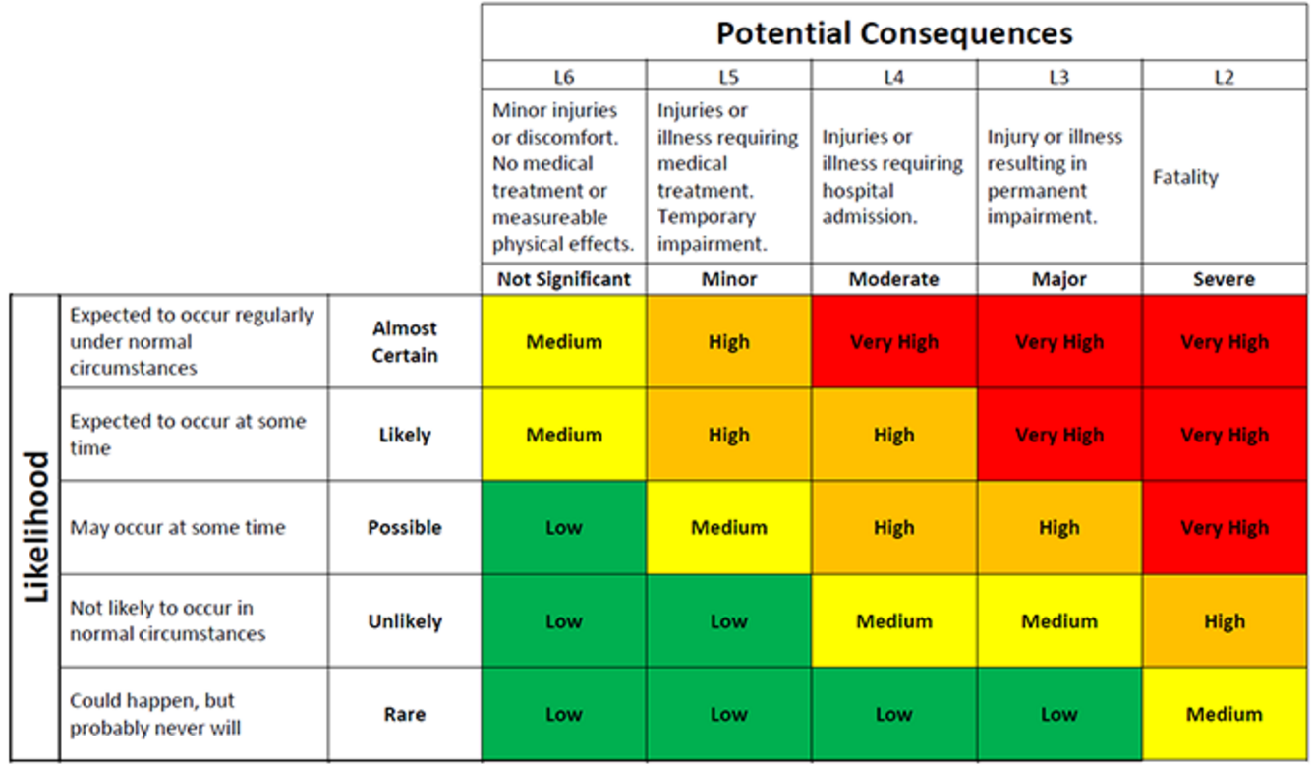
https://www.examspm.com/2016/08/16/risk-matrix-template/screen-shot-2016-08-23-at-12-47-10-pm/

The above risk assessment is used by adults and children for Forest School, this tool allows us to assess any activities and weigh up if the activity is safe to continue with, if the activity is judged to be in the green area it is a ‘low’ risk activity and therefore the activity can take place. If the activity is judged to be a ‘red’ high risk activity it must not take place. The ‘orange’ area which is a medium risk control actions must be put in place and a decision as to whether this activity can take place will be made. Specific risk assessments will be put into place for certain activities like tools.
Because the nature of Forest School is participant led, new risks may occur, in this scenario discussions can take place with children to enable us as a group to reach a sensible decision. The Forest School Leader will be qualified and will always be present for Forest School sessions.
There is a Forest School first aid bag and all necessary first aid equipment will be kept in this bag, any first aid incidents will be written down in the school first aid log book.

Accident and Emergency Procedure
All staff and adults will be briefed on what is to happen in an emergency situation. Children will be called back in the event of an emergency and asked to wait for further instructions. The Forest School leader will assess the situation and injury/accident. They will ensure the rest of the group are safe. If necessary (no other adult other than Forest School Leader is on site) the adult will phone for help or 2 older responsible children will be sent back to the school building to get another adult to help. An accident form will be filled in later. A RIDDOR record (the reporting of injury, disease and dangerous occurrences regulations) will be created along with an accident report for any death or serious injury.
In the event of a serious injury that cannot be treated with First aid:
- In serious circumstances the emergency services will be contacted using emergency phone carried by Forest School Leader, the school will then be notified and the school office will be responsible for contacting the injured person’s emergency contacts.
- Ensure the rest of the group are safe and moved away from any danger.
- A member of staff will meet the ambulance at the school gates and guide them to the incident.
- If the injured person is taken to hospital one member of staff should accompany them and the emergency contacts should be updated about the situation

Emergency contact numbers:
Fire/Ambulance/Police 999 – if dialling from the school office you will need to dial a 9 to access an outside line first, making the number 9999.
School Office 01553 774511
A RIDDOR and an incident form will be completed for any serious near misses in or on the way to the Forest School site. This will help inform any future risk assessments.
Children will be made aware what to do in an emergency situation so that if it is the Forest School Leader that is injured and in the unlikely event that they are unable to ring the school office for help the children will be able to return to the nearest school building (the mobile or classrooms inside the building) to seek extra adult help, this person will then follow the above procedure and contact the emergency services if necessary.
Minor Accidents/Incidents and First Aid procedure
The Forest School Leader has an outdoor first aid certificate and will always carry the first aid kit, in the event of a minor accident or incident, the Forest School leader will assess the situation and decide if all children need to put tools down, stop and come back together or if the accident can be treated whilst children continue (if there is another adult at the Forest School session they can continue monitoring the other children), the accident will be treated and afterwards the Forest School leader will complete an accident log (in the accident log book held in the school office), the class teacher will be informed and if necessary this can be communicated to parents.
Welfare
The health and safety and welfare of children during Forest School is essential, when children are given support and the basic needs such as food, water, toileting, warmth and rest it enables them to move onto psychological and self-fulfilment needs (as in Maslow’s hierarchy of needs). The child builds up a good relationship with others in the group and with the Forest School leader and this will give them the opportunity to achieve self-esteem, confidence and their potential, without a strong welfare system this does not work which is why the basic needs are a strong foundation for a Forest School programme. Forest School gives children many opportunities to learn new skills such as tool work and team building and to achieve challenges for themselves through reasonable risks, risk assessments are completed regularly and thoroughly and children can be involved in this process allowing them a sense of responsibility or their own risk, in this way risks can be reduced which allow children the freedom to explore and opportunity to learn new skills.
Toileting
The Forest School area is within the Howard Junior grounds at the edge of the playing field. Before children leave the school building they are encouraged to visit the toilet, however the nearest toilet is in the year 6 mobile or in the school so children can if needed visit the toilet.
Clothing
Forest School takes place in all weathers except thunderstorms or high winds. Children need to bring their Forest School kit along to school and will get changed before the start of sessions. Children and parents will be advised to dress sensibly according to the weather/season. In winter children will be asked to wear warm clothing like thick socks, hats, gloves, scarfs. In summer children will be asked to wear sun-cream to school but still wear long trousers for protection in the woodland. School can provide some clothing and have a small amount of spare clothing, waterproofs and wellies that children can borrow.
Drinking water
Children are asked to bring their school water-bottles to each session or can return to the school building for water.
Handwashing
A manual tap and soap dispenser will be available for children and adults to use when appropriate or children can wash hands when they return to school, hand sanitizer will not be used when sessions involve a fire.

Lost Children
Since the Forest School site is situated within school grounds at the edge of the school field this is unlikely however could be possible. The Forest School Leader will agree a sound or signal for all children to return to the fire circle in the middle of the Forest School, the children will also be aware of the boundary. If a child does go missing it is important it is reported, adults will first be informed and if there is a spare adult they will go and look for the child, if only 1 adult at the Forest School site other children will return to school whilst the adult stays and looks for the missing child, if the child can still not be found the school office will be informed and a larger party will search for the child. If the child is still not found police will be made aware. Adults and children must inform the Forest School Leader where they are going (back to school for any reason) and headcounts on a regular basis and at the end of a session to avoid this situation unnecessarily.
Uninvited Person/Stranger
In the event of a uninvited visitor on the site they will be asked to leave politely. If they refuse to do so and the Forest School leader feels that the children are at risk then the group will leave the site and return to school. The police will then be contacted as the visitor will be trespassing.
Cancellation Procedure
Forest School can take place in all weather with the correct clothing, except thunderstorms and high winds. It is important that the Forest School Leader is present for all sessions, if the Forest School leader is not present only outdoor learning can take place in the woodland area. Children need to bring in the correct kit and must have appropriate kit for the weather.
It is the Forest School Leaders decision is a session needs to be cancelled there are certain situations where Forest School may have to be cancelled:
- Forest School Leader is not present
- If there is not enough adults for Forest School to take place
- In extreme weather conditions such as thunderstorms or high winds (if wind speeds are above 40mph) Forest School will need to be cancelled or take place in an open space like the school field, mobile or in the eco-pod (outside classroom), wind speeds of 30mph or above will need to be monitored.

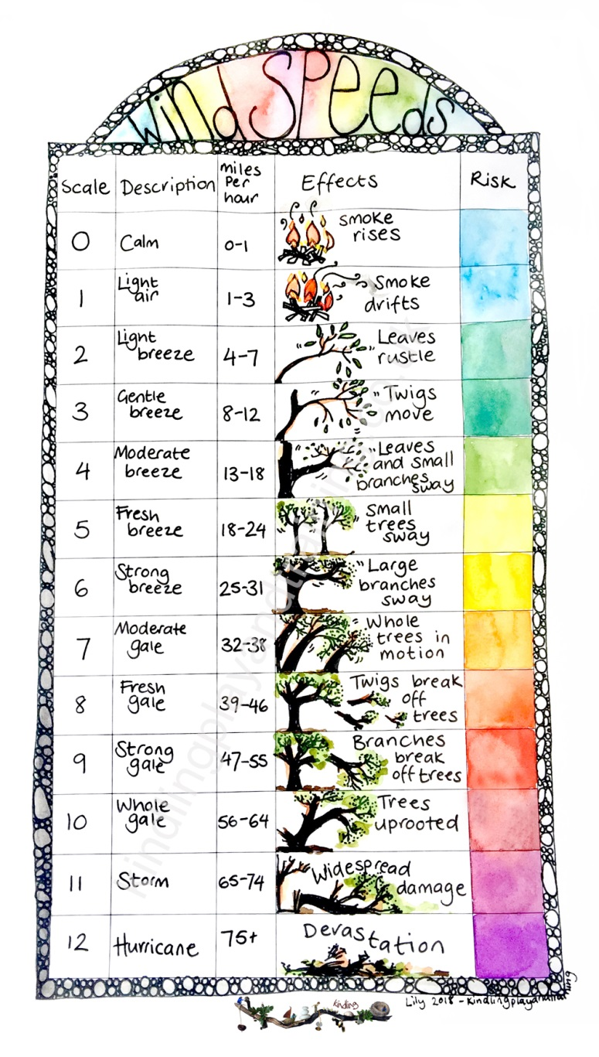

Responsibilities
- The Forest School Leader will communicate with the school to know that the correct level of insurance is valid, at the present time this is a yearly contract with Birnbeck insurance
- Forest School Leader will ensure the first aid kit and a mobile phone are always carried
- Forest School leader will ensure all daily risk assessments, site risk assessments, specific risk assessments and any other risk assessments needed will be completed and updated as necessary
- Forest School leader, office staff and teachers will work together to ensure all children have parental consent and ensure they have any medical/allergy information
- Teachers will ensure children are changed and ready for their Forest School session

Tool Policy
Allowing children the use of tools gives them self-esteem and confidence, it allows them to feel empowered and believe in themselves, it involves a managed risk which allows children to feel responsible for their own safety. It also teaches them life skills and physical abilities, they may feel a sense of purpose and accomplishment when creating using tools.
Tool rules
- Children must only use tools when instructed to by the Forest School leader, they will be supervised by the Forest School Leader or responsible adult
- Tools will need to be counted in and out
- Tool will start off on a 1-1 basis allowing the adult to closely supervised then if appropriate this ratio may increase depending on the ability/age/need of the children
- Tools will be kept in the Forest School shed which is secure and locked
- All tools are to be maintained appropriately and checked on a regular basis to ensure they are safe and in good working order by the Forest School leader, they will be checked before and after each use, children will understand about tools being safe and in good working order also
- Children and adults to be taught how to safety use tools and respect tools at all times
- No running with tools, tools must not be waved about
- Blade guards must be kept on tools when not in use e.g. knife sheath, bow saw cover
- Children must never touch blades
- Hair must be tied back, no loose clothing worn and no gloves to be worn whilst using tools
- Children must understand the tools safety rules including use of a blood bubble (space around person using tool so as not to touch anyone else) before using tools
- If Forest School leader says ‘tools down’ children must all put tools down straight away

Tools and safety instructions
Object | Purpose | Safety Instructions
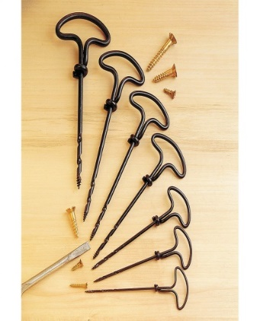 | Put holes in objects | - Forest School leader will demonstrate how to use safety in small groups of 1:1 when first using tool  - Children to be shown how to hold correctly on wooden block, keep vertical  - Keep hands safe and out of the way  - Do not wave object around or throw object  - Keep all gimlets together and visible with piece of ribbon on so they do not get hidden or not visible on Forest floor
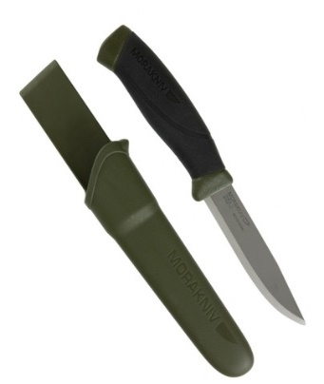 | Whittling wood, wood craft, food preparation | - Children to be shown how to correctly hold the knife  - Children to be told about the blood bubble rule (nobody within touching distance) and 3 point safety stance (must have 3 points of contact)  - Children to be shown how to use tool initially on 1:1 basis and under close supervision  - Forest School Leader will demonstrate keeping knife safety away from your body and moving knife away not towards body when using  - Do not wave object around or throw object
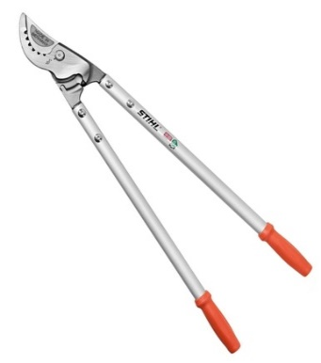 | For cutting branches | - Forest School leader will demonstrate on 1:1 basis and children use under close supervision  - Children to understand about blood bubble  - As tool uses both hands this is a good method to keep hands safe
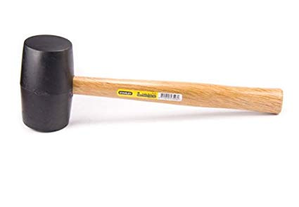 | For hitting objects into the ground, leaf bashing, den building | - Children to be shown how to correctly hold the mallet  - Children to be told about the blood bubble rule (nobody within touching distance)  - Children to be shown how to use tool initially on 1:1 basis or small groups  - Children to ensure they are in sturdy position  - Demonstrate other hand away from where you are hitting  - Keep face away from where you are hitting in case mallet bounces backwards
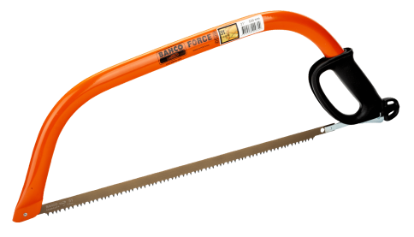 | For sawing wood or cutting branches, team work skills | - Children to be shown how to correctly hold the saw – knuckle grip and other hand in safe zone or also holding saw to have two hands on saw, also how to check saw blade cover  - Children to be told about the blood bubble rule (nobody within touching distance) and 3 point safety stance (always have 3 points of contact)  - Children to be shown how to use tool initially on 1:1 basis or small groups  - Children can use together to create a push pull action  - Children to create several cuts in same direction to minimise bounce of saw before sawing  - Do not wave object around or throw object

Fire Policy
Fire is really important and beneficial in Forest School, it is powerful and empowering, it can also help to bring warmth and togetherness through building, lighting, cooking, eating and drinking. It requires team work to collect the sticks, lay them in the correct way and then if supervised children enjoy experiencing lighting with the flint and steel.

Fire Safety
- The fire will be lit in a location that is safe, it will always be in the same place, in the middle of the Forest away from trees or any low hanging branches
- Tripping hazards will be removed-check fire circle area for any branches/twigs/sticks/weeds
- Log seats will be about 1.5metres away from the fire area, they will be sturdy and safe and there will be spaces in between to allow children to exit the fire circle safety
- Children must walk around the fire circle
- Fire safety equipment including a fire safety blanket and plenty of water will always be available when fires are lit
- Children will take part in a safety talk about fire and rules will be discussed and decided with the Forest School Leader

Fire Rules
- The Forest School leader will always be present when the fire is lit, ideally with another adult or if not in very low ratio groups of about 1:6, although this needs to be judged and possibly adapted by the Forest School Leader depending on age and ability of group, (the fire and storm kettle can be lit if only Forest School leader is present in some circumstances e.g. Forest School Leader assesses the situation to be safe, small group of children, children know the fire rules very well), the Forest School leader should light the fire, if children show they are responsible to light the fire this should be risk assessed and supervised
- Children should not throw anything in the fire, objects such as bamboo sticks and additional sticks for the fire can be placed in the fire when instructed by Forest School Leader
- Sitting in the line of the smoke must be avoided, if the fire does smoke where children are sitting they may get up and walk to the nearest exit then walk around the outside of the fire circle to find a more suitable seat away from the smoke
- Children may approach the fire when the Forest School Leader has instructed them to do so, they kneel next to the fire and this should be a maximum of 3 children at a time
- Children must not wave objects about for example hot sticks, skewers, hot food
- Fires will be lit with matches, fire flint or fire steel
- Hand sanitizer must not be used when having a Forest School fire – instead children and adults can use water and soap to wash hands
- The safety fire equipment must be brought when lighting a fire, this must include the fire blanket, heatproof gloves, fire first aid equipment – for treating burns etc, plenty of water and fire rules sign

Putting the fire out
- All fires must be put out before the group leave the Forest School area
- Ideally fires would smoulder down to embers/ash and then water should be slowly poured on the fire to put it out
- All pieces of wood will be separated and spread out using a larger stick
- There must be no smoke or steam left and the fire area will be cool to touch when the extinguishing is finished
- Once the fire is out, cool and there is no smoke the group is then free to leave the Forest School area
- All fire equipment including the safety equipment is to be packed away and stored securely in the Forest School shed

Fire Equipment and safety instructions
Object | Purpose | Safety Instructions
 | Used for cooking items over the fire e.g. marshmallows | - Do not wave around  - Children to understand that one end is sharp and pointed  - Do not share skewers  - Use long skewers and ensure children hold it as near to the top as possible so fire is further away from hands  - Do not put food cooked on skewers straight into mouth, check heat with fingers and wait for food to cool down if necessary
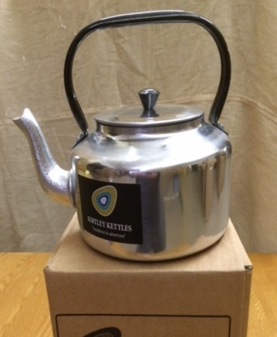 | Boiling water for hot drinks etc | - Remind children that kettle will be hot as metal conducts heat  - Adult must place and remove campfire kettle from fire either on a grill or tripod  - Adult to use heat protective gloves to place and remove kettle using the handle  - Remind children that water that comes from kettle will be boiling and to keep fingers away  - When pouring place cups/mugs on floor and remove hands in case kettle spills  - Ensure kettle is not too full so water does not spill out or splashes when boiling and also not too empty  - Be careful of steam coming from spout and do not lean over kettle  - Ensure lid is on kettle and wait until kettle has cooled to remove lid  - Ensure kettle is places securely and is steady on fire
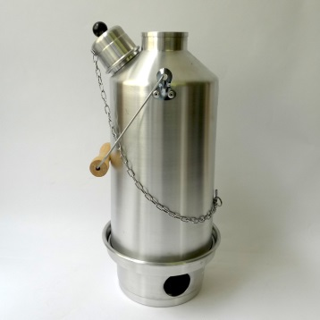 | For boiling water | - Remind children that kettle will be hot and not to touch, also water will be boiling so as with a campfire kettle only pour into cups on the floor or on wooden stumps in case of spillage or splashing  - Remove cork  - Only pick up storm kettle using handle and fire safety gloves but keep it at the side and do not hold over the top as there will be steam
 | Hot food and drink | - Remind children that food and drink cooked over the fire will be very hot, remind them to let their food or drink cool down first, adults to advise when food or drink is ready to taste  - Food must be stored appropriately before session – inside in school  - Food products and food preparation equipment (plates, chopping boards) to be kept in box with lid on to ensure they are clean  - Hands washed or sanitised before eating
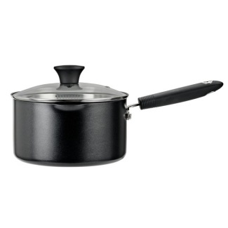 | To cook food over fire | - Remind children that the pan will be hot as it conducts heat so only touch handle to hold  - Children must use utensils to stir food in the pan under supervision of an adult(using fire safety gloves if necessary), stir slowly to avoid splashing and from the side, do not lean over as there may be hot steam coming from the top  - Do not let pan cook with nothing in or burn food
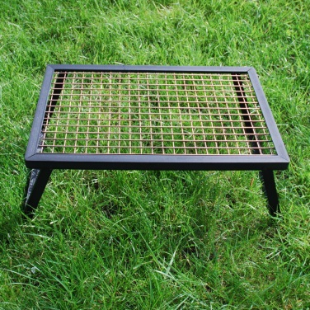 | To cook food, hold campfire kettle | - Remind children that metal conducts heat and grill will be hot to touch so do not touch with hands – only use utensils or safety gloves when adding or removing food  - Follow the fire rules by only approaching grill when adult gives permission and kneel near fire pit  - Ensure grill is in a safe and steady position  - Do not touch even when fire is out as it will still be hot – use safety gloves

Food Hygiene Policy
- Children or adults involved in cooking, food preparation or eating will be asked to wash their hands with water and soap
- Equipment that will be having food on (chopping boards/plates) will all be clean and kept in the cooking box (plastic box with lid on)
- Food waste to be disposed of inside school to minimise rodents in Forest School area
- Food must be appropriately stored before use – within school premises inside the building and in fridge or freezer if appropriate

Child Protection and Equality

Safeguarding Procedure
The DSL’s are Mrs Hopkins, Mr Paull, Mrs Ketteringham-McCourt, Mrs Leadley and Mr Smith. We report any concerns about a child’s physical or mental well-being promptly just as we do in school and fill in CPOMS. The forms must be filled accurately and in as much including dates, times and signed digitally by whoever is filling in the form. No leading questions should be asked to the child. The Safeguarding and Child Protection Policy will be followed just as it is within classes in the school. Any concerns will be treated confidently and only shared with class teacher and safeguarding team who can ensure correct channels can be informed.
The safeguarding and child protection policy is available on the school website. Forest School is run by a trained Forest School Leader, everyone involved is briefed on health and safety and risk assessments of site and activities.
If concerns are raised about a child’s physical or mental well-being the adult or member of staff will fill in CPOMS, if there is a spare staff member this adult can take over for a very short period whilst the safeguarding team is informed, if not urgent the safeguarding team will be informed at the end of the session (at present Forest School sessions are between 1.5-2 hours) but ensure it gives safeguarding team time to deal with concern, if necessary children can be taken back to class rooms early if there is no spare member of staff present at Forest School and safeguarding team informed immediately.
At Forest School we are aiming to build a trusting and non-judgemental atmosphere and because of the lower ratios of children to adults there may be more time and a greater likelihood of disclosure.

Equal Opportunities and Inclusion in Forest School
Forest School operates in line with the school policy, this can be found on the school website. We promote the individuality of all children and adults irrespective of ethnicity, attainment, age, disability, gender or background. Activities that can be adapted to suit all children’s needs will be, and information on children's needs can be gathered prior to the sessions. Wherever possible reasonable adjustments will be made to accommodate children with allergies, medical and behaviour needs, this may include extra staff, adapting activities or adapting the site. All children must feel their experience is worthwhile and this will help one of the main aims of Forest School to increase their self-esteem and confidence. The site is at the end of a concrete path and therefore unless it is a particularly wet and muddy day the site is accessible to wheelchair users.

Behaviour and Anti-Bullying Policy
At Forest School we encourage children to be kind and respectful towards each other and adults. Children will be reminded of this frequently and positive behaviour will be encouraged. Children at Forest School must feel safe and happy and if there are any unwanted behaviours this will be reported to the head teacher or SLT member by the Forest School Leader and discussions will take place.

Use of photographs
Children at Howard Junior receive a letter when they start at the school which includes consent to share photos and videos on the website, social media or in the newspaper. Only the children with permission will be able to have photos and videos on the website blog or in the newspaper. Only school I-pads and cameras can be used to take pictures/videos of children at Forest School.

Parental consent and agreement
Parents will be given a letter with information about Forest School (appendix 3) along with a leaflet about the ethos, procedures example of the activities and clothing needed. There will also be a permission slip on the bottom that parents must return before their child takes part in Forest School. There will be a section on the school website about Forest School and the website blog will be updated weekly when sessions have taken place to encourage parents to engage and understand Forest School.

Communication with staff and others
The Forest School leader may need to speak to staff (class teachers and SLT) about any issues with children or relevant information, this should either be done in person ideally or by the secure school email. Miss Newell has held a staff meeting to introduce and give staff members an idea about what Forest School is about and also holds well-being staff meetings (such as Christmas well-being session). If any maintenance work needs carrying out it is to be written or verbally communicated to Mr Holden (the caretaker).

Confidentiality Policy and Procedures
All Forest School staff and adults will need to follow the confidentiality policy.
- All adults will need to be made aware of any allergy or medical conditions of children that attend Forest School, this information will be kept alongside the Forest School handbook and will be kept confidential on a need to know basis
- The School office have all children’s details and contact numbers
- Only trained First aiders will be able to administer first aid to any children, staff and volunteers will need to be made aware of this
- All adults attending will need to make the Forest School leader aware of any relevant medical conditions, this will be treated with complete confidentiality
- Trained staff will be able to take notes and assessments of children attending for any well-being notes and any further planning information (Forest School is about following the children’s interests)
- All personal information will be kept confidential and stored appropriately

Daily operating procedure
Before Forest School session
- Check weather and if enough adults available
- Daily risk assessment of the Forest School area and read through the specific risk assessments for that session
- Check planning and inform other adults
- Put out resources needed for sessions (including safety items e.g. first aid kit)
- Have a list of children including medical/additional needs

Collect children
- Collect children from classrooms
- Children get changed into their Forest School uniform (t-shirt)
- If children need additional clothing (particularly cold or wet weather) go to shed and get dressed in appropriate clothing (wellies, waterproof jacket and trousers, spare clothes to add layers in the cold)
- If children have not got appropriate clothing for the Forest School session it may be that they cannot take part that session
- Children to bring water bottles and iPads with them
Beginning
- Walk from shed to Forest School area and play some games along the way or on the field
- Read through rules together to re-cap
- Gather around the fire circle for the start of the session, talk about activities available
Middle
- Children choose what activities they would like to do during that Forest School session
- FS Leader and other adults to model activities that children can choose from
End
- Tidy up Forest School session ensuring we put everything back where it was (FS leader to check all tools have returned)
- Gather around the fire circle to reflect upon today’s session
- Return to school, wash hands and get changed
After the session
- Share any photos on the twitter page
- Add session write up to FS log book
- Return to Forest School area to tidy and return resources to shed
- Clean tools, organise resources in shed, organise resources for next session, making sure there are enough resources for next time (first aid kit resources, safeguarding forms etc)
- FS Leader to evaluate and reflect on the session, using children’s interests and skills to help plan and prepare for the next sessions
- FS Leader to plan for next session

Environmental/Sustainability
The Forest School site at Howard Junior will be used regularly for Forest School sessions on a Monday and a Tuesday. Although the site can be used by other staff, this is infrequent so the site usage is minimal.
The site was first cleared for Forest School sessions and the grounds contract staff will help to maintain this so growth does not reach to such a level that Forest School sessions cannot take place.
Flora and fauna will be left to develop mostly and new flora will be implemented.

